Multi-tier architecture:

Application-level or middleware: has an application server, which is used to find requested data and services, makes them available for viewing, and carries out transactions.

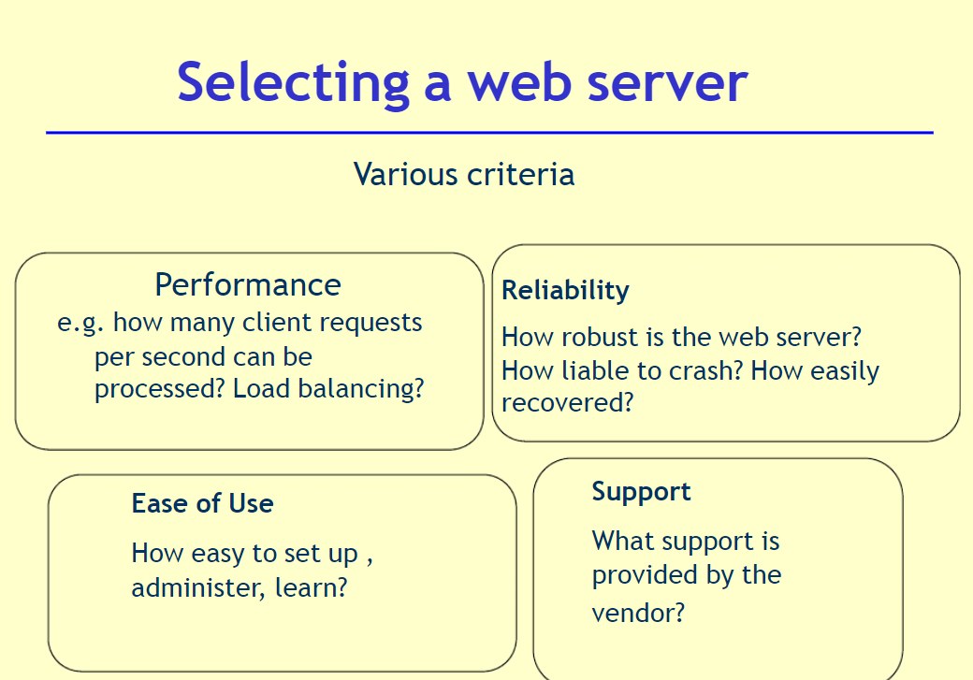Data and service level: has a variety of data and services accessible by the application serve

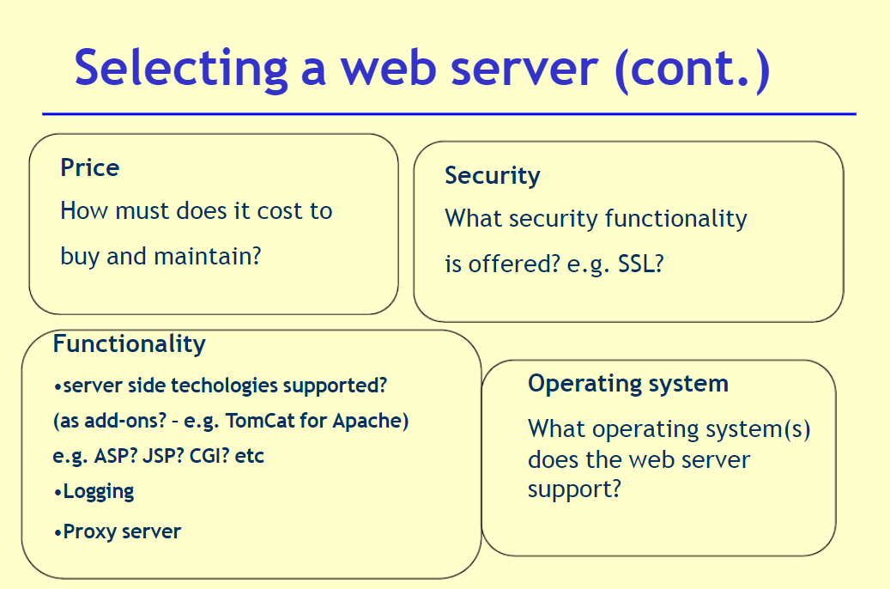

<h1>Login To Your Account</h1>

<?php

require_once "db_book.php";

echo "<form id=\"form4\" method=\"post\">";

echo "<fieldset><legend>Contact form</legend><p class=\"first\">";

echo "<p class=\"first\">";

echo "<label for=\"userName\">User Name:</label>";

echo "<input type=\"text\" name=\"userName\" maxlength=\"21\" size=\"30\">";

echo "</p>";

echo "<p>";

echo "<label for=\"password\">Password:</label>";

echo "<input type=\"password\" name=\"password\" maxlength=\"6\" size=\"30\">";

echo "</p>";

echo "<p>";

echo "<p class=\"submit\"><button type=\"submit\">Submit</button></p>";

echo "</fieldset>";

echo "</form>";

echo "</tbody>";

$result = mysqli_query($db, "SELECT * FROM users");

if ( isset($_POST['userName']) && isset($_POST['password']))

{

$u = mysqli_real_escape_string( $db, $_POST['userName']);

$p = mysqli_real_escape_string( $db, $_POST['password']);

// To protect MySQL injection

$u = stripslashes($u);

$u = stripslashes($u);

$u = mysqli_real_escape_string($db,$u);

$p = mysqli_real_escape_string($db,$p);

$sql="SELECT * FROM users WHERE userName ='$u' and password ='$p'";

$result=mysqli_query($db,$sql);

// Mysql_num_row is counting table row

$count=mysqli_num_rows($result);

// If result matched $u and $p, table row must be 1 row

if($count==1)

{

// Register $myusername, $mypassword and redirect to file "home.php"

$_SESSION['userName'] = $u;

$_SESSION['password'] = $p;

header("Location:Home.php");

}

else

{

echo "Wrong Username or Password";

}

}

ob_end_flush();

?>

<br>

<br>

<a href="register.php">Not registered an account?, click here</a>

</center>

</body>

</html>

Web Life Cycle Model

STAGE 1: define the mission of the web site and the user population

STAGE 2: Collect the user requirements of the web site

STAGE 3: Create the conceptual design of the web site

STAGE 4: Create the physical design of the web site

STAGE 5: Perform usability testing on the web site

STAGE 6: Implement and Market the Web Site

STAGE 7: Evaluate and improve the site

<?xml version="1.0" encoding="UTF-8"?>

<breakfast_menu>

<food>

<name>Belgian Waffles</name>

<price>$5.95</price>

<calories>650</calories>

</food>

<food>

<name>Strawberry Belgian Waffles</name>

<price>$7.95</price>

<calories>900</calories>

</food>

<food>

<name>Berry-Berry Belgian Waffles</name>

<price>$8.95</price>

<calories>900</calories>

</food>

<food>

<name>French Toast</name>

<price>$4.50</price>

<calories>600</calories>

</food>

<food>

<name>Homestyle Breakfast</name>

<price>$6.95</price>

<calories>950</calories>

</food>

</breakfast_menu>